Oxygen Precipitation in Silicon

Virginia Semiconductor, Inc.
1501 Powhatan Street, Fredericksburg, Va 22401
(540) 373-2900, FAX (540) 371-0371
www.vriginiasemi.com, tech@virginiasemi.com

A Introduction
The following paper is an overview of the journal article “Oxygen Precipitation in Silicon” by A. Borghesi, B. Pivac, A. Sassella, and A. Stella found in the Journal of Applied Physics, 77 (9) in May 1995.

B Overview
The behavior of oxygen in silicon is extremely complex, and the reader is advised to review the comprehensive article shown in Figure 1 [1].
All Czochralski (CZ) grown silicon uses a quartz crucible to support the liquid silicon during crystal growth. The crucible is rotating, and a rotating silicon seed is dipped into the liquid and slowly pulled from the melt. As the seed is pulled, directional freezing of perfect, single-crystal silicon occurs. An ingot of silicon results from the pot of molten silicon. During crystal growth, the molten silicon etches or dissolves the quartz generating oxygen doping. The oxygen is dispersed throughout the crystal and can cluster to form precipitates and complexes. The oxygen is a recombination center for free carriers, generally behaves as an n-type dopant, and actually strengthens the silicon. Therefore, the oxygen has both good and bad behavior.
Many semiconductor devices require the maximum carrier lifetime, longest carrier diffusion length, and largest possible carrier mobilities. These devices include ICs, solar cells, microwave diodes, photodiodes, and discrete power devices. For these applications very low oxygen is needed and typical CZ silicon can offer oxygen concentrations below 30 PPMA. For some devices such as photodiodes, microwave PIN diodes, and high efficiency solar cells the oxygen in CZ silicon is unacceptable, and Float Zone (FZ) material is required. The FZ process does not use a crucible, but locally heats polycrystalline ingots and re-freezes the ingot into single crystal silicon. Therefore, FZ material is essentially void of oxygen and very pure.
Also, many Microelectromechanical Systems (MEMS) and devices, or silicon sensors are manufactured using silicon micromachining. For this technology, the silicon complexes result in deep etching anomalies and poor machining yields. Therefore, low oxygen level crystals should be used for micromachining (<30 PPMA). More importantly heat treatment of the CZ silicon for extended times at 700C-900C should be avoided. Under these process temperatures, VSI believes that the oxygen combines or grows into large complexes, and the complexes greatly interfere with the etching process. Even very low oxygen crystals can show poor etching if heat treatments force the oxygen to coalesce. The amount of oxygen in any CZ crystal varies from the top of the crystal to the bottom of the crystal and the low concentration end should be used when micromachining is intended.
Oxygen in silicon strengthens silicon. As a result, CZ silicon is stronger than FZ silicon and wafer breakage will be reduced using CZ material. This is particularly true when thin silicon wafers are being processed (<300um). Furthermore, CZ silicon is much less expensive than FZ silicon (2-10 times as expensive).

C Figure 1

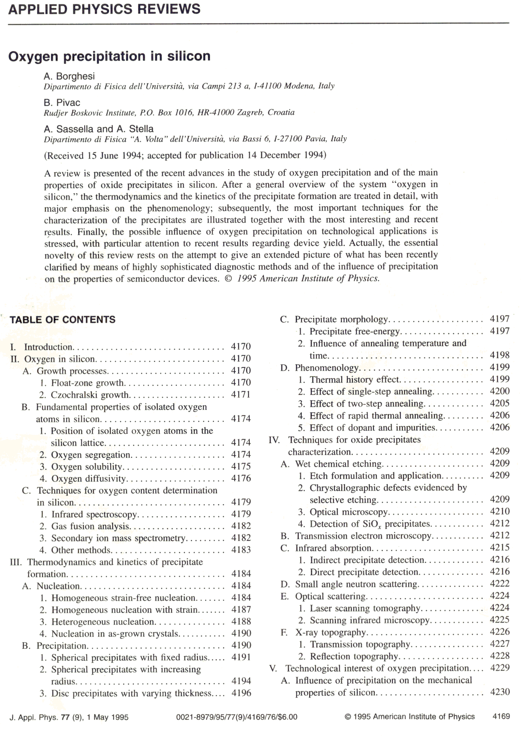

D. Summary

All CZ silicon ingots contain oxygen and the presence of oxygen in silicon has both positive and negative effects. Most technologist and users of silicon benefit from reduce oxygen concentrations. When extremely low concentrations of silicon are required, FZ should be used. The behavior of oxygen in silicon is very complicated and the reader is referred to reference 1.

[1] “Oxygen Precipitation in Silicon” by A. Borghesi, B. Pivac, A. Sassella, and A. Stella found in the Journal of Applied Physics, 77 (9) in May 1995.

